Case Studies

Version : 1.0

Document Owner : Richard Raju

Document Control Information

 | Role | Name | Date
Document Prepared by |  | Richard Raju

Reviewed by

Approved by

Revision History:

Version  Number | Revision  Date | Description of Changes
1.0 | 05-11-2011 | Initial Version

Course Details

Course Name | Open source and Open Standard
Semester | First
Credits | 2
Chapter | 5
Delivery Duration | 2 Hour

Table of ContentS

1 Introduction 5

2 Case study 1: Mozilla 5

3 Case Study 2 – Linux 7

3.1 Linux Distribution 7

3.2 Development Model 7

3.3 Change Rate 8

3.4 Who writes the Kernel? 9

3.5 Why companies support kernel development? 9

3.6 Linux Dominance in industry 10

4 References 11

5 Disclaimer 12

Introduction

In this final chapter of the open source topic we will discuss few case studies on how open source phenomenon has helped to developed applications which are not only free but have better reliability, scalability and security. This also demonstrates the strength of community driven approach to develop applications. First we will look at Mozilla case study and see how one man speech changed a company business model from closed to open source. Second case study we will learn how Richard Stallman inspired a 21 year old Linus Torvalds, future developer of Linux Operating system and make it open.

Case study 1: Mozilla

O'Reilly, publisher of O'Reilly & Associates, a company specializing in software manuals and software-related books invited Raymond (Author of “Cathedral and the Bazaar, See chapter 2 “History of Open source”) to deliver a speech in their conference. O'Reilly intention was to use Raymond’s speech to educate the audience and motivate them on free software development.

As expected, the audiences were shell shocked to see the growing power of free software movement. Among audiences was a small group from a startup called Netscape. They were the developer of then popular proprietary web browser Netscape Navigator. They were the competitor for Microsoft web-browser. Inspired by Raymond’s speech, the Netscape group took the message back to office. With this elevated inspiration and zeal to win the web-browser market, during January 1998, Netscape announced to open the source code for the Navigator web browser. The code name for Navigator's source code was "Mozilla".

The name Mozilla was chosen to commemorate an army of developers and the size of the code itself, 30 million lines. Mozilla developed as a branch of Mosaic, a proprietary web browser created by Marc Andreessen at the University of Illinois.

When Netscape management decided for an open source business model, it had lot to do than just publishing the Navigator web-browser source code. For the Mozilla project to succeed it needed a robust open development process. Few Netscape employees who are familiar with open source became the founding members of Mozilla Corporation. The first step after the formation of Mozilla Corporation was creation of Mozilla.org. Brendan Eich, one of the founding member of mozilla.org and remains the technical and philosophical leader of the project to this day. Mozilla team started with a clean slate to change the development process from closed to open. As with most open source project, the early steps were to create mailing list, newsgroups, and bug tracker. Tracking bug was a separate open source project under Mozilla (http://www.bugzilla.org) and they also build system to automate the process of builds and rebuilds of software code on multiple platforms ((http://tinderbox.mozilla.org/showbuilds.cgi).

Mozilla created a crisp development methodology which can be traced to the last bit of code to the developer. They have created a single window to access all this information in http://tinderbox.mozilla.org/showbuilds.cgi. Here are few of the tracker parameters;

- Who created the code?
- Who reviewed the code?
- What was the issue or the bug the code addressed
- What code changes were made?
- When was the code checked in, at what time?
- When was the defect detected?

With all this in place, still they needed a good product to prove that Mozilla is determined to create a powerful web-browser. After several years of development, Mozilla 1.0, the first major version, was released in 2002, but not many people were using it. Mozilla project created the Mozilla Foundation in 2003 to create awareness among users. During 2004 Mozilla community release first version of web-browser called Phoenix later renamed as “Firefox 1.0”. This was a big hit across widest possible set of people. Mozilla riding on the same success of firefox, developed Mozilla Thunderbird, e-mail client software.

Firefox

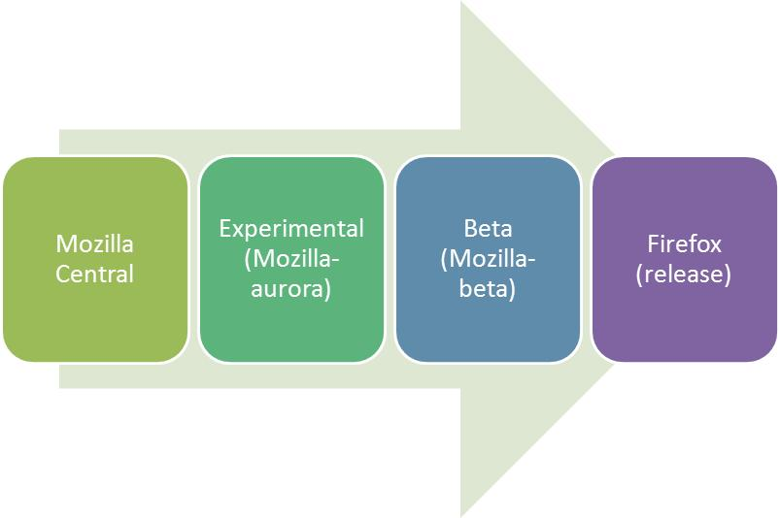
Here is a quick look at Mozilla development process. They use schedule-driven process, meaning the release happens regardless of whether a given feature is ready or not.

Mozilla Central: All changes to source code are collated here. At a predefined schedule, changes are moved to beta channel to be accessed by wider audience as beta release.

Experimental: Mozilla-aurora is frequented with many features at regular intervals and they are tested, if they fail to work they are disabled. Features that are disabled or miss the schedule are pulled again in the next schedule cycle.

Beta: All the features which have passed the experimental stage are incorporated into beta release.

Visit this link to read in-depth about the development process http://mozilla.github.com/process-releases/draft/development_overview/

Many have debated whether open source development can produce quality applications. Mozilla Firefox and Thunderbird demonstrate that open source software can indeed produce great open source product.

Exercise:

- There are so many web-browsers available, find out how can a user have an option of selecting a browser of his choice?
- What is an e-mail client and how it works?
- What is a bug and who can detect it?

Case Study 2 – Linux

In 1990, Richard Stallman visited Polytechnic University in Helsinki, Finland to voice the philosophy of free software movement. Among the audience was a 21 year old Linus Torvalds, future developer of Linux Kernel, liked the idea of sharing the code.

During 1991, Torvalds took the Minix operating system and rewrote it by adding features and released it as a first version of Linux. During January 1992 Torvalds decided to adopt the GPL as a standard license for Linux. This was a major decision that Torvalds made. He chose it because it’s already proved by the community. He knew that this will remove the restriction on charging for distribution costs, but it also invoked the GPL “viral” clause, which ensured that any new software built with Linux code would have to be released with source code under the GPL as well and would remain free code forever and no proprietary organizations can use it for their profit.

The operating system has been improvised since its inception by the contributions of the open source community. Torvalds became the chief architect of the Linux Kernel and now acts a project’s coordinator for Linux Kernel development.

Linux Distribution

Linux quickly evolved from a single-person project to a world-wide development project involving thousands of developers. One of the most important decisions for Linux was its adoption of the GNU General Public License (GPL). This prohibited the misuse of the source code by the commercial vendors and nurtured the open source community for its rapid development.

A typical Linux distribution comprises of linux kernel and many application programs and tools along with documentation. Many system level and user level tools found in a Linux distribution come from Free Software Foundation’s GNU project. Both the linux kernel and the GNU suite of applications are released under the GNU General Public License (GPL). Linux distributions have taken multiple forms – fully featured desktop, server , mobiles and laptops. There are two categories of distributions:
- Commercially backed – Fedora (Red Hat), openSUSE (Novell), Ubuntu(Canonical Ltd.)

and Mandriva Linux(Mandriva)
- Community driven – Debian and Gentoo

Development Model

In 2005, a loosely coupled time based development model was introduced, where a new release occurs every 2-3 months. When the mainline release is made, the development community continues to work on the Linux next tree. Linux next serves as a staging area for the next development cycle. If the main line contains the changes for release 2.6.X, then the linux next contains the changes intended to be made for release 2.6.X+1. The developers can glance through the staging area to determine changes/features being implemented in the next development cycle and be prepared for the integration issues that may occur.

After each release, there is a short term maintenance that is performed by the stable team. The maintenance period is equivalent one development cycle which is roughly under twelve weeks. The stable team is responsible to apply the critical fixes to the defects reported and release them to the users and distributors. They are also responsible to apply the fixes to the future mainline releases as well.

Change Rate

The Linux kernel which forms the core of the Linux operating system is a result of contributions from over 1000 developers and 200 corporations. The rate of change in the kernel is increasing rapidly with the passing of each day because of the openness nature of Linux.

Each developer changes only on a small logical piece of code which adds lines of code, deletes lines of code or modifies the lines of code, which is termed as patch. Each patch when applied should produce a properly working kernel. The patch is not directly passed onto the mainline instead it will apply to one of 100 subsystem trees. For eg., a subsystem tree exists for networking, drivers or architecture code etc., Each subsystem has a maintainer who controls the changes made to the subsystem tree. The patch is reviewed for its correctness and signed off by the maintainer. When a patch is accepted to the subsystem, a “Signed-off-by” line is attached which indicates that the patch can be legally merged to the mainline.

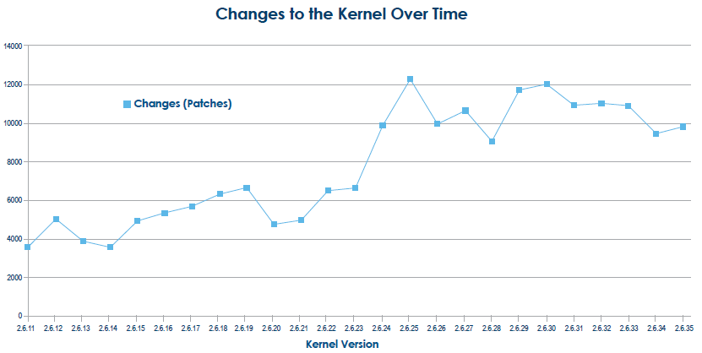

On an average there are 4 to 5 patches applied to the kernel tree per hour. As mentioned earlier, when a new kernel is released, defects will be reported and patches will be released that contains the fix for the problem. The stable kernel update process was designed to capture the patches in such a way that patches are applied to the current release and the mainline kernel. The stable updates acts as a base for the distributor kernel.

Who writes the Kernel?

There are over 1000 developers and 200 corporations who are sponsoring the work of the linux kernel development with the significant contributions being made from the individual developer community. The Pareto principle, well known as the 80-20 rule is applicable to the contributions made by developer community. Even though there are over 1000 developers, top 10 developers have contributed to the 10% of the total changes and top 30 developers have contributed towards 22% of the total changes. The snapshot below shows the top 10 contributors making 70% of the total changes to the kernel.

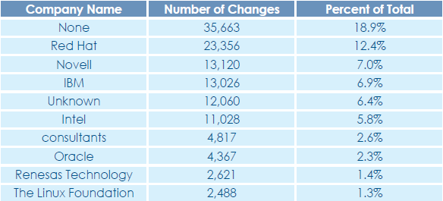

The “None” category represent individuals that are doing the kernel development work on their own interest without the financial benefit from any organization. The “Unknown” category represents developers whose corporate affiliation cannot be determined.

Why companies support kernel development?

In the earlier section we read about successful firms contributing towards the development of kernel. Each of these firms have their own self interests in supporting the kernel development of Linux because it provides competitive edge in the markets.

- Companies like IBM, Intel etc., are working to ensure that Linux runs and performs well on their hardware enabling increased sales on the offerings that are linux based.
- Distributors like RedHat and Novell have clear interests in making Linux kernel better and robust.
- Companies like Sony and Nokia are working because they ship linux as a component of products in mobiles, television sets etc.,

Linux Dominance in industry

Linux is no more limited to being a desktop operating system. It has made its way to the production environment across multiple industry verticals like Chemical and Petroleum, Education, Finance and so on. The following is the data from Top500.org which shows the dominance of Linux in the Super Computing industry.

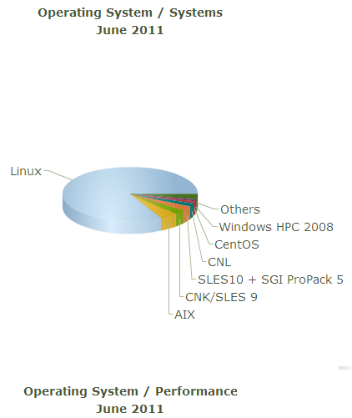

The Linux operating system is one of the largest and most successful open source projects that has proven open source development model is effective. The sheer quantum of developers contributing towards the improvement of Linux and the rate at which changes are incorporated is remarkable in the technological realm.

Exercise:
- Both Red Hat Enterprise Linux (RHEL) and Fedora are backed by Red Hat, Inc. What is the difference between the two?
- What is a monolithic kernel?

Cited References

http://www.mozilla.org/about/history.html

The success of open source by Steven Weber

Free as in Freedom by Sam Williams

http://commons.oreilly.com/wiki/index.php/Open_Sources_2.0/Open_Source:_Competition_and_Evolution/The_Mozilla_Project:_Past_and_Future

http://www.linuxfoundation.org

Disclaimer

The contents of this report reflect the views of the author and do not necessarily reflect the official views or policy of the International Business Machines Corporation in the United States and/or other countries. This report does not constitute a standard, specification or regulation.

IBM is a registered trademark of International Business Machines Corporation in the United States and/or other countries.

Other company, product, and service names may be trademarks or service marks of others.

Microsoft is a registered trademark of Microsoft Corporation

